Source / Version Control Systems:

Git installation:

1. Select as shown below

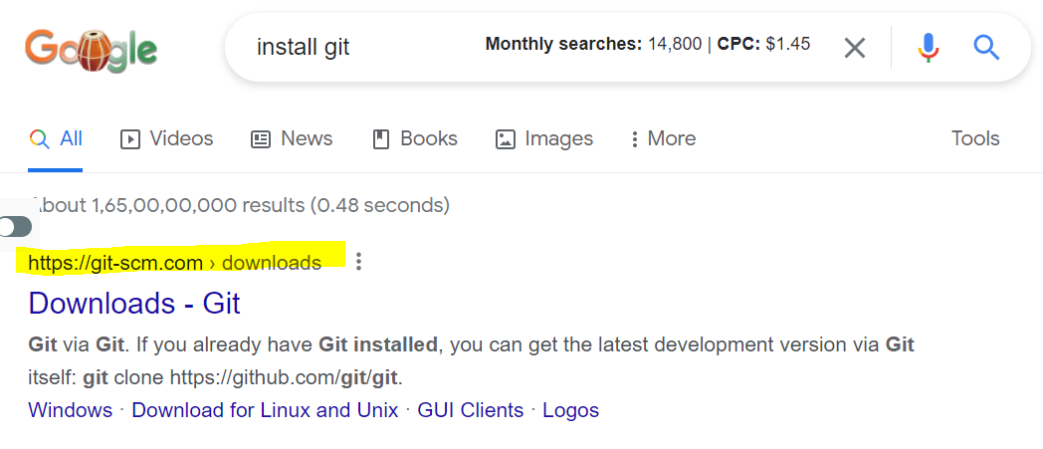

1. Select based on your OS
2. Select 64 OR 34 based on your OS

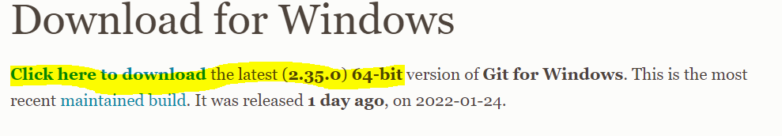

1. Open exe file once downloaded
2. Click on Yes from popup message
3. Click on Next from popup message
4. Click on Next again
5. Click on Next again
6. Click on Next again
7. Click on Next again
8. Click on Next again
9. Click on Next again
10. Click on Next again
11. Click on Next again
12. Continue keep clicking Next
13. After all Next click on Install

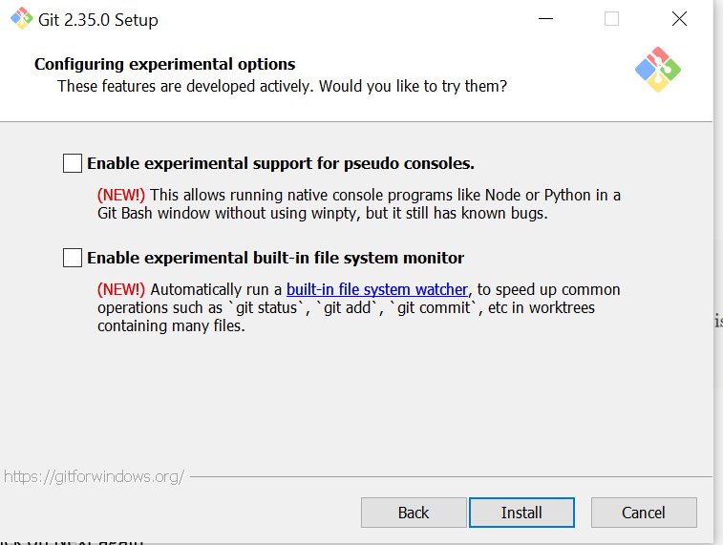

1. Click on Finish

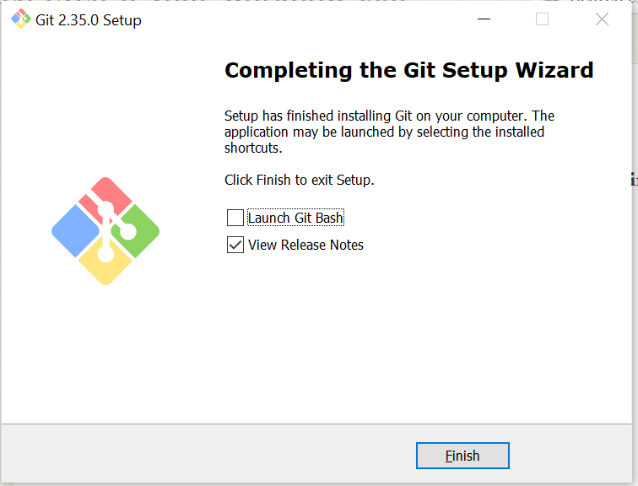

1. You will see below screen

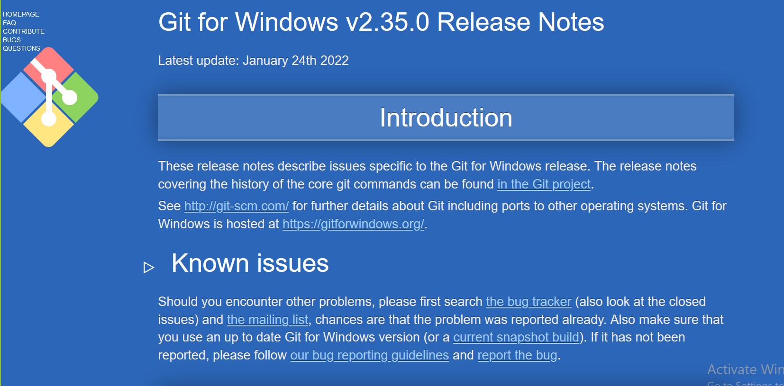

1. Open browser and type URL as shown below

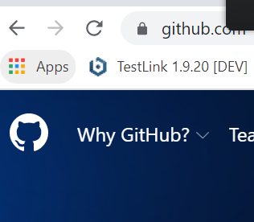

1. Click on 
2. Enter your email id an click on Continue

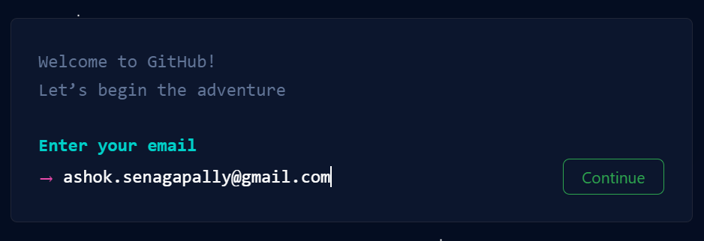

1. Enter password and click on continue

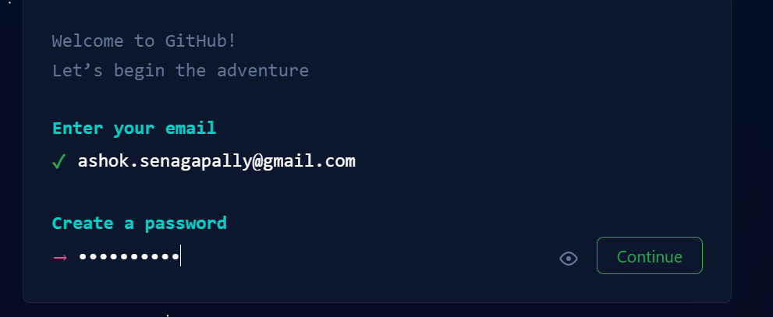

1. Enter user name and click on continue

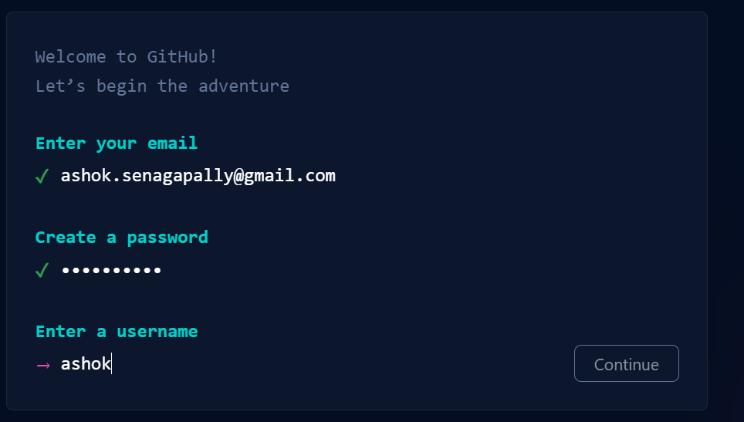

1. Type as show in below and click on continue

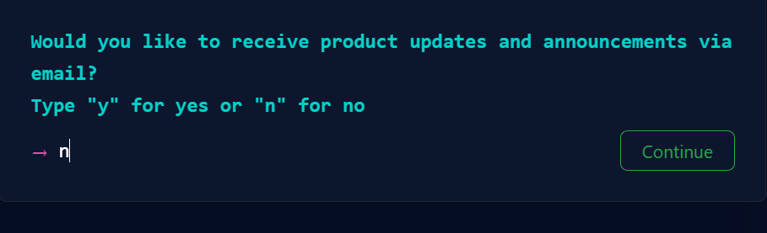

1. Click on start puzzle

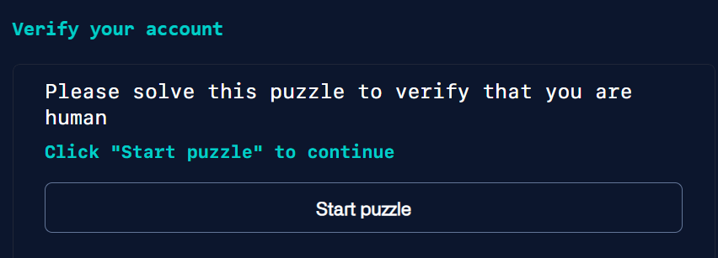

1. Continue as per the puzzle and click on create account

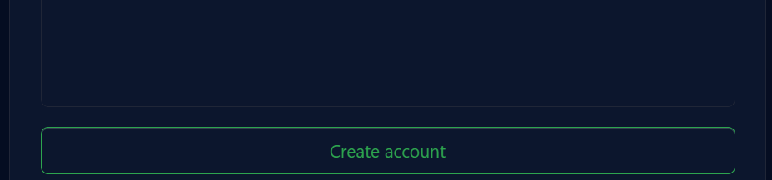

1. Open gmail and login with user id and password to confirm account
2. Follow instructions given I mean open your email to get code
3. Type in Code
4. Then select as shown below

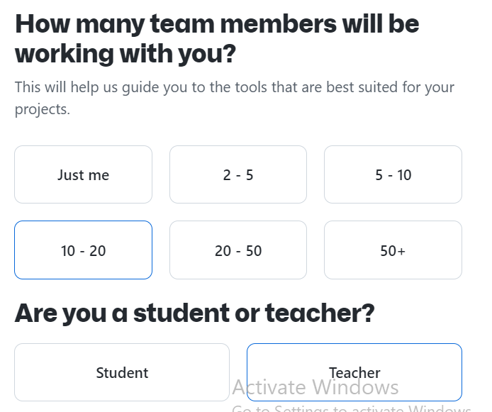

1. Click on Continue button
2. Click on Continue button



1. Click on skip



1. Click on Create repository

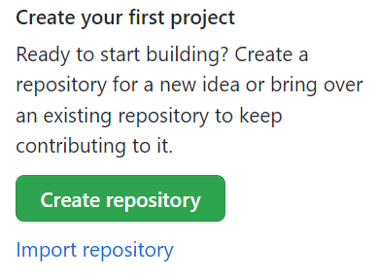

1. Enter repository name and click on create reposiory

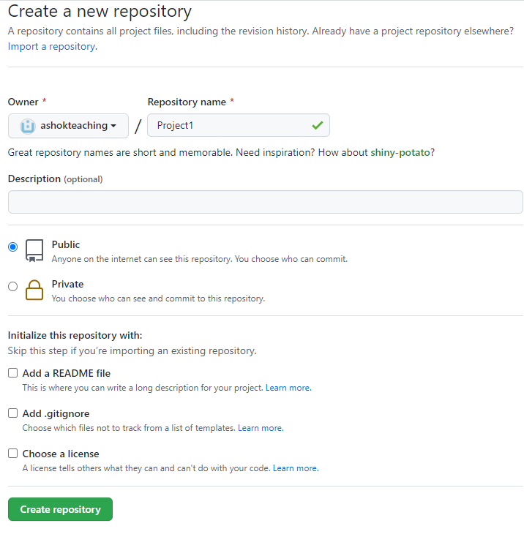

1. You should see below screen

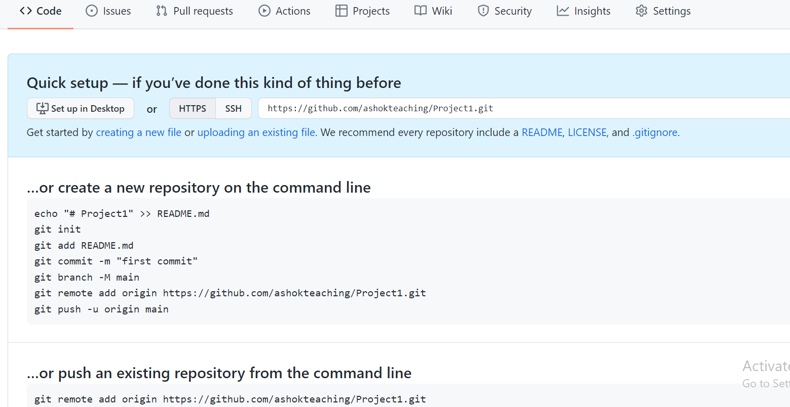

1. Now open Eclipse and right click on your project select properties



1. Click on as shown below



1. Double click on your project
2. Right click inside the window and select as get bash here

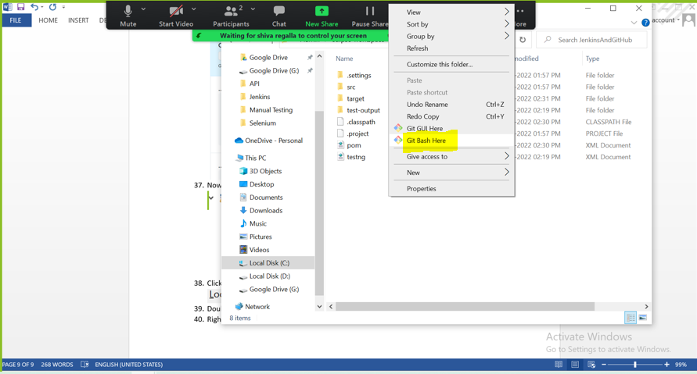

1. You will see below screen

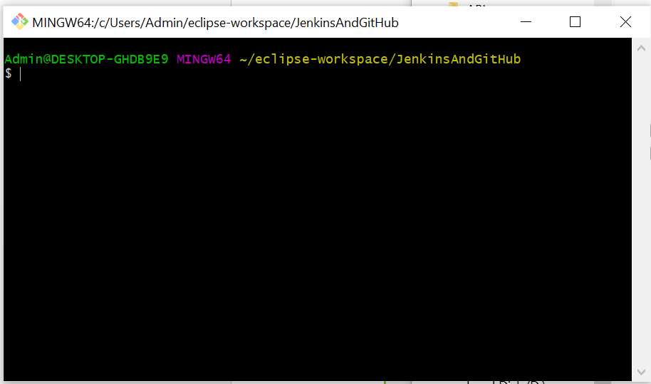

1. Type git init

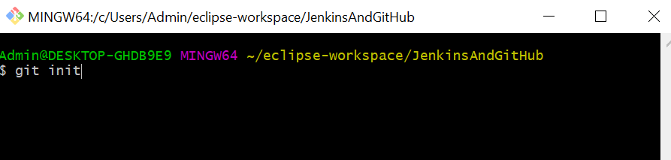

1. You would see below response

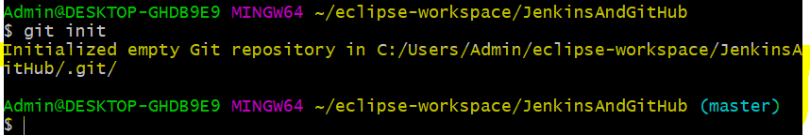

1. Go to opened browser and copy text which is shown below

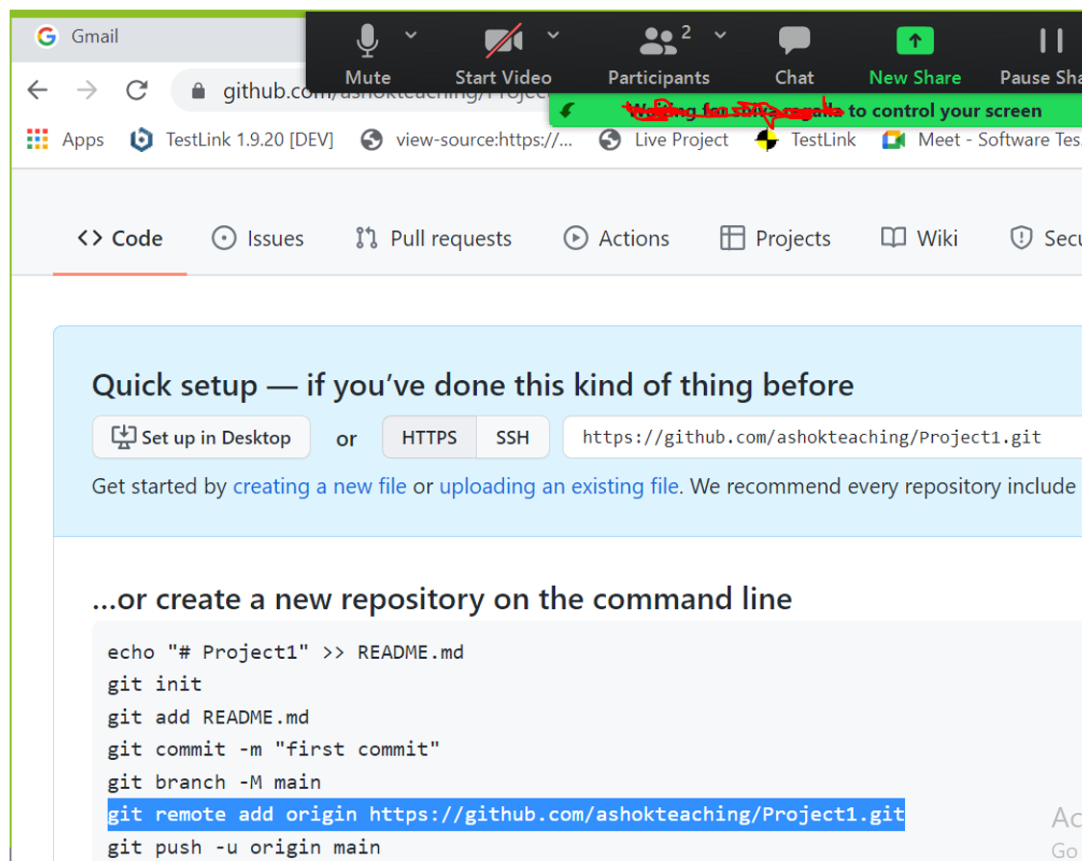

1. Go to git bash here window and paste as shown below



1. Type git status and you would see below response, it means that nothing is added to git bash of now

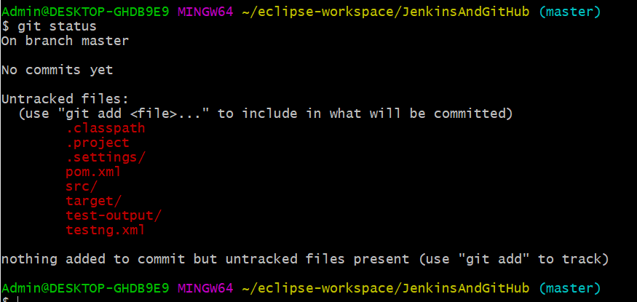

1. Type git add. And you will get below response, it means that your local project is added to Git repository

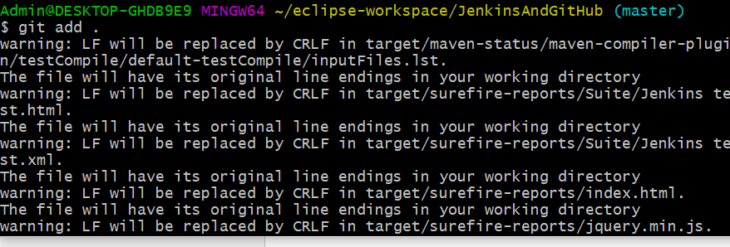

1. Type as shown below and you will get below response

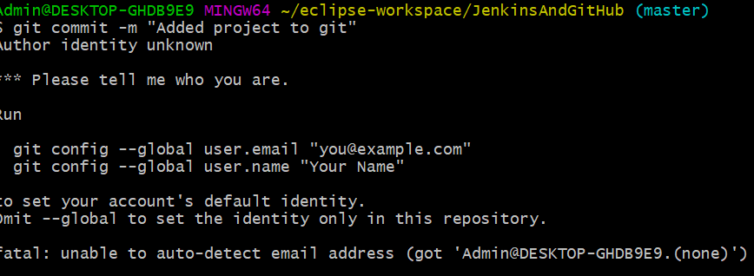

1. Type as per below(based on your email)



1. Type as shown below



1. Type as shown below and you will see below response

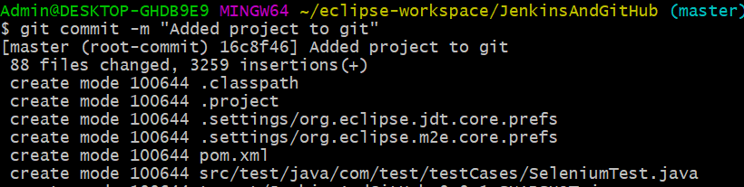

1. Follow the remaining steps as suggested
2. Type as mentiioned below

$ git push -u origin master

1. Go to Chrome browser and see code should be available there